ATM SIMULATOR – PROJECT REPORT
Submitted By:
Name: Siddhesh Pitale
Roll No: 73
College: Yeshwantrao Chavan College of Engineering
Github url: https://github.com/Siddheshpitale/ATM-Simulation

Certificate
This is to certify that the project report entitled “ATM Simulator Using Java Swing” is submitted by Roll No. 73, in partial fulfillment of the requirements for the course/project. The work embodied in this project is original and carried out under the guidance of the faculty.

Acknowledgement
I would like to express my sincere gratitude to my respected teachers and the Computer Engineering Department of Yeshwantrao Chavan College of Engineering for providing me with the opportunity to work on this project titled “ATM Simulator Using Java Swing.”
I am especially thankful for the support, encouragement, and necessary resources provided throughout the development of this project.

Abstract
This project focuses on developing an ATM Simulator using Java Swing for the user interface and Object-Oriented Programming (OOP) concepts for backend logic.
It provides essential ATM operations such as depositing money, withdrawing cash, checking account balance, and viewing transaction history.
The purpose of this project is to understand GUI development, encapsulation, event handling, and secure user authentication.

1. Introduction
An Automated Teller Machine (ATM) is a widely used banking device that allows users to perform financial transactions without visiting a bank branch.
This project simulates the basic functions of an ATM system using Java Swing.
The main objectives of this project are:
- To understand GUI development in Java using Swing.
- To implement encapsulation and classes in Java.
- To simulate essential ATM functionalities.
- To understand event-driven programming.

2. Problem Statement
Banking systems require secure, user-friendly interfaces for transaction processing.
This project aims to design a simplified ATM model that allows:
- Account creation
- Login authentication
- Cash withdrawal & deposit
- Balance inquiry
- Maintaining transaction history
The system is suitable for beginners to learn GUI and OOP in Java.

3. Technologies Used
Component | Technology
Programming Language | Java
GUI Toolkit | Java Swing
Concepts | OOP, Encapsulation, Event Handling
Development Environment | Any Java-supported IDE (NetBeans, IntelliJ, Eclipse)

4. System Requirements
Hardware Requirements
- Laptop/PC with minimum 2 GB RAM
- 500 MB disk space
Software Requirements
- JDK 8 or above
- Any IDE (optional)
- Windows/Linux/Mac OS

5. System Architecture
5.1 UML Class Diagram
+----------------+ +---------------------+
| Account | | ATMSystem |
+----------------+ +---------------------+
| -username | | -accounts: HashMap |
| -pin | +---------------------+
| -balance | | +createAccount() |
| -history | | +login() |
+----------------+ +---------------------+
| +deposit() |
| +withdraw() |
| +getBalance() |
| +getHistory() |
+----------------+

+----------------+
| Transaction |
+----------------+
| -type |
| -amount |
| -date |
| -balanceAfter |
+----------------+
| +toString() |
+----------------+

+----------------+
| LoginFrame |
+----------------+

+----------------+
| DashboardFrame |
+----------------+

6. System Modules
6.1 Account Module
- Stores username, PIN, balance, transaction history.
- Provides deposit and withdrawal methods.
6.2 ATM System Module
- Manages all user accounts using HashMap.
- Performs authentication and account creation.
6.3 Login Module
- GUI for entering username and PIN.
- Validates user credentials.
6.4 Dashboard Module
- Displays buttons for deposit, withdrawal, balance inquiry, and transaction history.
- Handles all user interactions.
6.5 Transaction Module
- Stores detail of each transaction such as:
  - Type (Deposit/Withdraw)
  - Amount
  - Date & Time
  - Balance after transaction

7. Working of the System
7.1 Account Creation
The user enters a username and PIN.
If the username is unique, the system registers the account.
7.2 Login
The system checks:
- Username exists
- PIN matches
If valid → Dashboard opens.
7.3 Deposit Money
- User enters deposit amount
- Amount added to balance
- Transaction saved
7.4 Withdraw Money
- System checks sufficient balance
- Deducts amount
- Saves transaction
7.5 Balance Inquiry
Shows current account balance.
7.6 Transaction History
Displays all past transactions in a dialog box.

8. Screenshots
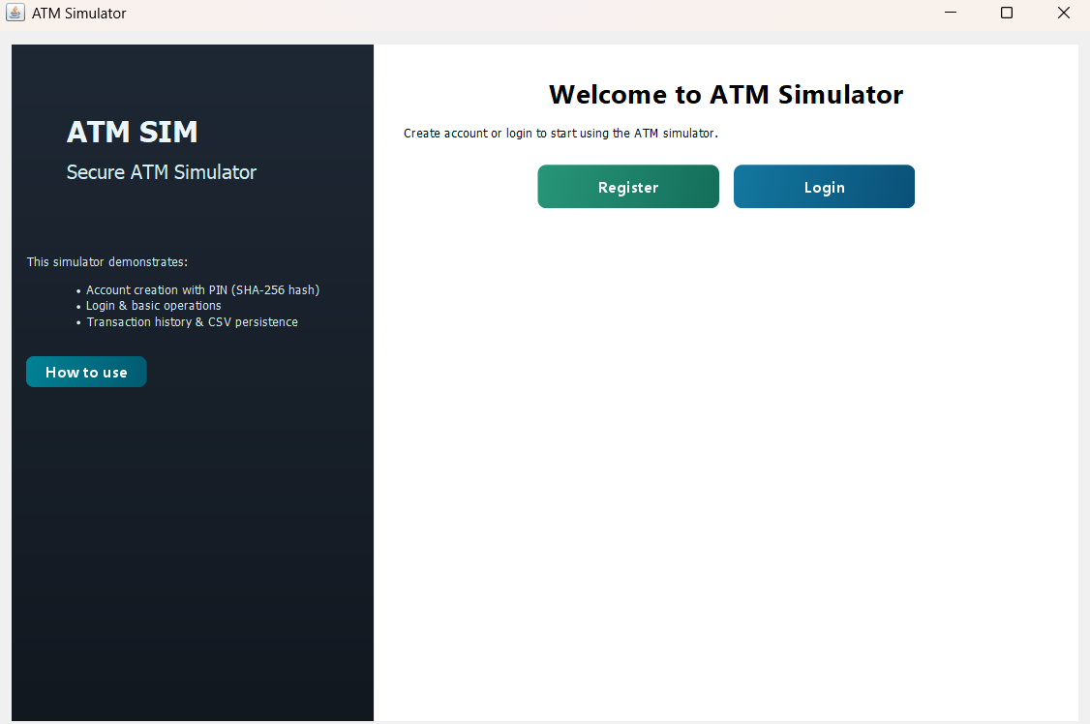
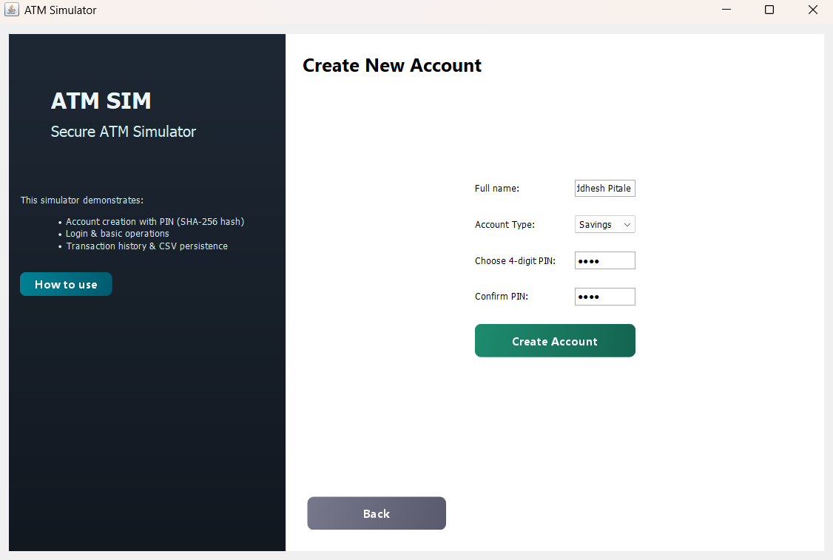
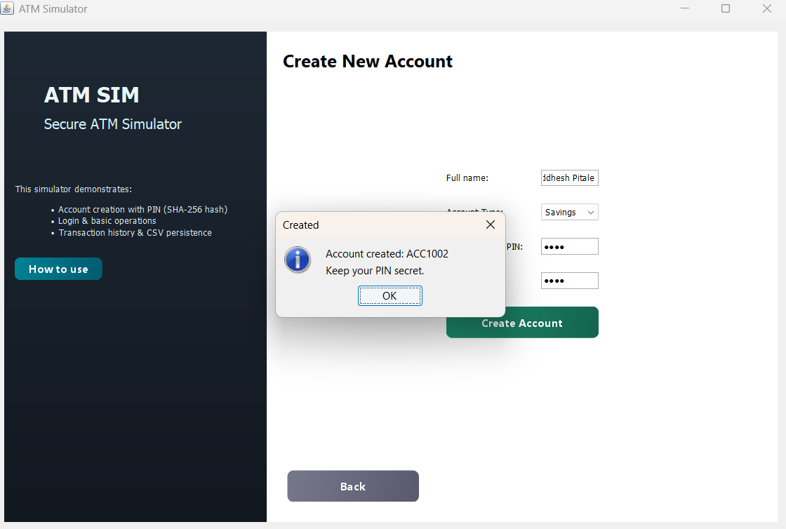
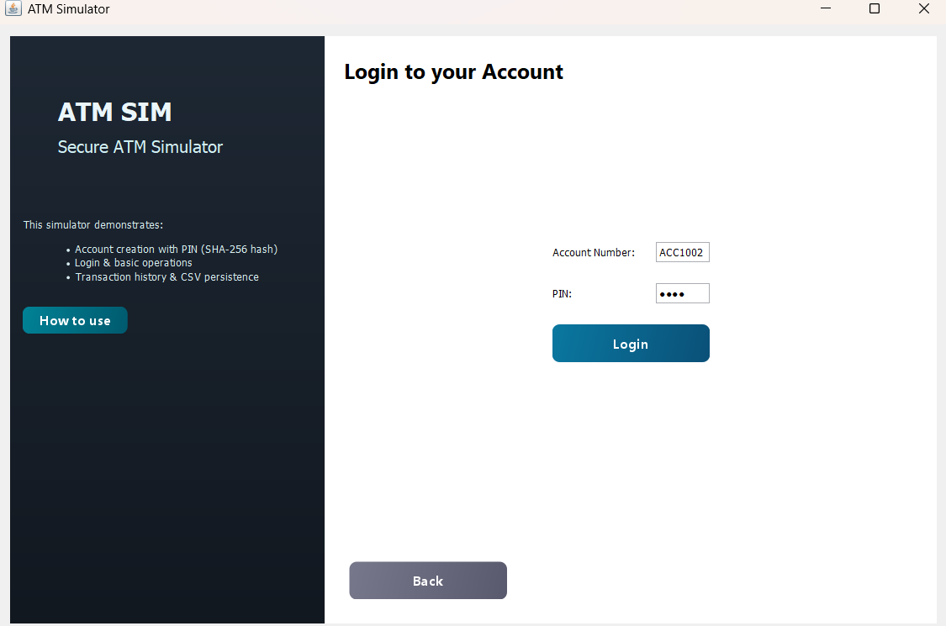
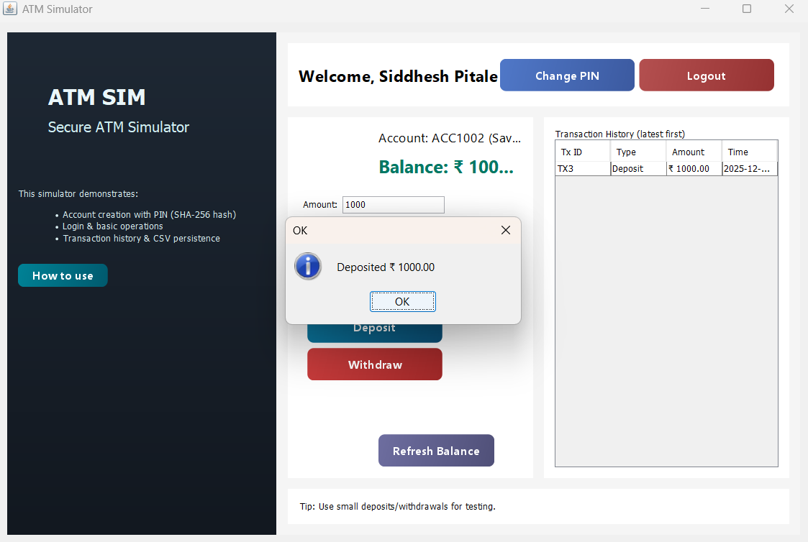
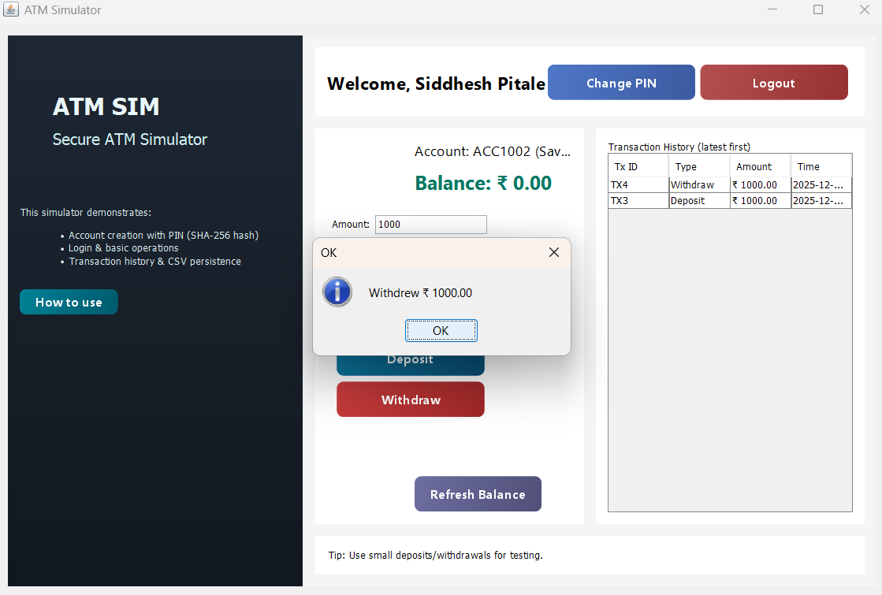

9. Advantages
- Simple and user-friendly interface
- Good demonstration of Swing components
- Helps in understanding real-life ATM systems
- Demonstrates OOP concepts clearly

10. Limitations
- No file/database storage (data resets on program restart)
- No security encryption for PIN
- Does not support multiple concurrent users

11. Future Enhancements
- Integration with SQL Database
- PIN encryption using hashing
- Adding mini-statement print option
- Improving GUI design
- Adding fund transfer feature

12. Conclusion
The ATM Simulator project successfully implements basic ATM features using Java and Swing.
It demonstrates knowledge of GUI programming, event handling, OOP concepts, encapsulation, and basic transaction processing.
The system is easy to use and can be expanded into a more complex banking application in the future.

13. References
- Java Swing Documentation – Oracle
- Core Java Volume I – Fundamentals by Cay S. Horstmann
- Online Java tutorials (GeeksForGeeks, JavaTpoint, W3Schools)

